FADS AGM 2020
Tuesday 27th October 2020 online, via Zoom
commencing at 7:30pm

MINUTES

In the Chair via Zoom: Cindy Gray.
Present via Zoom: Andy Barr, Kevin Boland, Margo Campbell, Denver Chalmers, Laura Cranstoun, Gerry Eckersley, Tony Flisch, Lorna Flisch, Anna Foran, Ian Kidd, Rowena Laing, Jonny North, Gavin Paterson, Ellen Ross, David Smith, Jane Stephenson, Sarah Walker, Jeannie Woodburn.
Present via phone: Sheila Fraser.

- Welcome and apologies
Cindy welcomed everyone and acknowledged the unusual circumstances of the meeting. There were apologies from Barbara McLeod, Jackie Smith & Rosie Walters.

- Minutes of 2019 AGM
  - Matters Arising
    - Tidying of Green Room, Lighting Loft & Dunny
The Green Room and Dunny tidying were completed through the last year and Tony confirmed the Lighting Loft is also now much tidier.
    - Sports Club Social Membership fees
Ellen reported that the Sports Club had accepted a smaller overall amount of money for the 2020-21 year and that the new JotForm online form process we have adopted has had some teething issues: some members have been unclear about what they need to do and Sandy says he has not received some of the forms. Sarah suggested that, as the JotForm system is fully automated, perhaps some had gone astray in the Sports Club admin system. It was agreed that the online system is better and we should proceed with it, but that we should try to work with the Sports Club to ‘iron out’ the teething issues - @Kevin to put on agenda for next meeting.
    - Legal requirements governing children in productions & new production etiquette forms
Ellen reported that the new paperwork system is working well, other than a few people needing to be chased up, but acknowledged that it was a significant job for the panto with so many children involved. David said that it would put him off directing unless he had a producer or other support to handle the admin. Cindy suggested we look at whether it can be simplified, and reinforced the importance of ensuring directors have support in this area - @Kevin to put on agenda for next meeting.
The 2019 Minutes were proposed by David and seconded by Jane.

- Chair’s report
Cindy gave the Chair’s report – attached at the end of these Minutes.

- Treasurer’s report
Cindy confirmed that the 2019-20 accounts had already been circulated to Members, finalised and sent to OSCR in July. There was just one query from Sheila, who said she couldn’t see our usual repayment to SCDA of any expenses we receive from them. Ellen confirmed we had received £305 from SCDA relating to travel expenses but had not reimbursed that. @Kevin to put on agenda for new committee to discuss whether we’re happy to keep going with this policy of reimbursement.
Ellen said that, considering we’d had costs for Calamity Jane and no income for the production, the account balances are looking healthy.
The 2019-20 accounts were proposed by Jonny and seconded by Sarah.

- Membership fees
There were no objections to the fees staying the same:
Adult £20.00 / Junior £5.00 / Primary £1.00

- Productions
  - Ticket costs
Cindy relayed the Committee’s suggestion that prices remain flexible and should be set for each production by the Director, in consultation with the Committee.
Andy expressed concern that the Club had been underselling itself on some productions, in particular the three one-act plays in September 2019, which were priced at £5.00 a ticket. Jane reported she’d paid £10 at Gartmore drama club and Gavin said he was surprised when he joined the club how cheap our tickets were. David and Kevin both felt it was important that we did all we could to ensure a full audience, and were both very much in favour of special deals. Kevin reinforced that the club isn’t meant to be turning a huge profit and suggested introducing special deals for Club Members who book early, to encourage attendance. Tony expressed disappointment that more members don’t pay to come along to support the Club’s productions and suggested we set a base minimum price for tickets.
Anna brought up the Macrobert’s policy on film screening evenings for the audience to pay what they think it’s worth and Laura confirmed the price options: £4.50, £6.50 and £9.50. Jane felt administering something like this would be too difficult for us. @Kevin to put on agenda for further discussion at the next meeting.
  - Admin/booking fee for online tickets to be passed on to buyers
As other clubs are charging an admin fee and we have incurred fees ourselves since moving our tickets online, it was agreed that we should pass on this cost to our audience. Sarah confirmed the TicketSource charge is 84p for a £10 ticket and said there is an option to simply pass this straight on to the buyer. Another option would be to simply add a flat fee of e.g. 70p to the ticet price and absorb any extra cost ourselves. @Kevin to put on next agenda.

- FADS logo
Sarah introduced the idea of updating the Club logo, as she felt the current image is a little sinister! She presented three different colour options of an initial design suggestion to get a feel for whether members would like a change, as it had only been discussed at Committee so far:

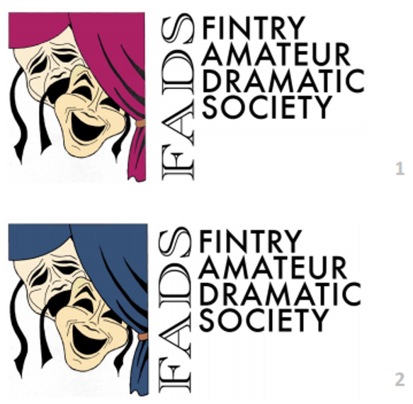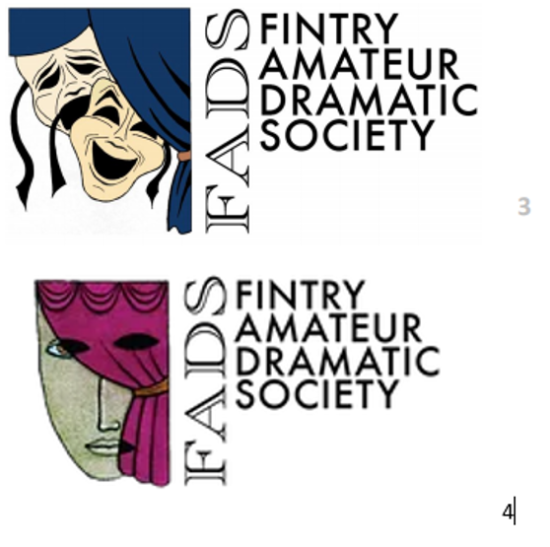

Gerry asked whether anyone knew the origin of the current logo, so we can ensure that we don’t lose something significant. Sheila said that the very first logo had actually featured two masks.
Comments from members included: liking the original one; not liking the design of the masks; feeling it’s a little fussy and the ribbons should be removed; perhaps just an update of the single mask would be sufficient; having the ability to change the colour of the logo with each production colour scheme.
A poll was taken, and 14/20 people voted, with the results:
1 – 64%
2 – 7%
3 – 0%
4 – 29%
Acknowledging that this had been a good discussion and that there did seem to be some appetite for change, it was agreed that Sarah would put forward some more ideas in due course - @Kevin to put on agenda for next meeting.

- Election of 2020-21 Committee
Cindy confirmed that Sarah was continuing for a second year as Secretary and that Laura and Rowena would both be happy to stay for a second year. Cindy and Ellen were both stepping down after two years as Office Bearers; Jane was also stepping down as an Ordinary Member after two years, and Paul’s resignation in March created a second Ordinary Member vacancy.
  - Chair
Kevin was nominated; he said there were three key things he would like to pursue as Chair and if there was support for these, he would be happy to stand:
- Taking productions out into the community
- Exploring the possibility of negotiating a piece of land at the Sports Club and erecting our own costume, props and set store.
- Considering changing the name of the club to make it more inclusive for the wider area, in the way that the rugby club based in Fintry is called ‘Strathendrick’.
Kevin was proposed by Laura and seconded by Ellen. With no other nominations, he was duly elected as Chair.
  - Treasurer
Cindy stated there had been no nominations for Treasurer from any members who had previously served on the Committee, but that Anna would be very happy to take on the role. Although the Constitution states that the Treasurer will ‘normally’ have previously held a Committee position, Cindy reiterated that these are not ‘normal’ times, which the majority of those present agreed with, and Anna stated that she has served as secretary on two other committees in a voluntary capacity.
Anna was proposed by Jonny and seconded by Gavin. With no other nominations, she was duly elected as Treasurer.
  - Ordinary Members
Laura was proposed by Jane and seconded by Sarah.
Rowena was proposed by Andy and seconded by David.
Cindy confirmed that there had been two advance nominations, from Andy and Gerry, and Kevin reminded the meeting that Jeannie had also said she would like to put herself forward. Cindy said that it was always hard to be in a situation where just one person might not get elected and asked whether any of the three might be happy to step back until the next AGM in six months, so we could avoid having to vote.
Tony suggested co-opting a fifth member onto the Committee; Sarah confirmed there was nothing in the Constitution regarding this, simply that it stated there should be four Ordinary Members. There was broad support for extending the committee, and Tony suggested that the Constitution could be adjusted later.
Cindy suggested proceeding with electing all three to the Committee, which Kevin agreed with, with amendments to the Constitution to be discussed at the next meeting.
For the election of Gerry, Jeannie and Andy, the proposer was Jonny and the seconder was Kevin.
@Kevin to put discussion about amending the Constitution on the agenda for the next meeting.

- Future productions
  - Christmas 2020-2021
Ian confirmed he’s working on some Roaches Coaches Christmas songs to put online.
Jeannie confirmed she’s working on ‘Beauty & The Beanstalk’ for panto 2021, and planning online readings of the script over the next couple of months.
  - SCDA One-Act Festival 2021
Tony reported that they’re trying to delay the Festival as much as possible to give it the best chance of being able to go ahead post-Covid. The British Festival has been tabled for September and it’s being left up to the Divisions to work out their own schedules. He said the entry deadline in November is very flexible.
The Housebound team confirmed they’re keen to return as our entry. Gavin emphasised that it’s a good option for the club as the vast majority of the work has already been done, so it means we’re not wasting time and resources on a new production that might not be able to go ahead.
  - Calamity Jane
Cindy confirmed that the production has been rescheduled twice and it looked unlikely we will be able to stage it in March. She said there had been some discussions about doing something with it online – perhaps excerpts or songs. Tony mentioned we need to be careful about copyright issues.
  - Mamma Mia & Rapunzel
Mamma Mia was something Kevin was considering, but he said he didn’t think we’d get performing rights as the professional production is taking place in 2021.
Cindy confirmed we have Ian & Laura’s Rapunzel in the pipeline for panto 2022 and summarised that we seem to have plenty of material and enthusiasm going forward. Andy added he felt it was important for us to press ahead and keep making plans to keep spirits up and have things to look forward to.

- Club social events
Cindy reported that the Committee had been discussing things that we could do online to bring the club together, as we won’t be able to socialise in person this Christmas – maybe a quiz. Kevin suggested everyone dresses up and comes to Zoom with a turn, e.g. a poem, song or reading.
Tony highlighted the importance of keeping drama going and said there is concern from clubs around the country seeing their membership decline over the pandemic.
Cindy suggested we re-activate the Social Committee, which currently comprises Ellen, Rowena, Anna & Jackie. @Kevin to put pre-Christmas social on agenda for next meeting.

- AOCB
  - Other activities
Cindy referenced FADS members participating in other activities/projects outside the Club, which is great for the community and good PR for the Club, but requested that the Committee is informed, so we can ensure FADS promotes them.

Cindy concluded by emphasising how important it is to keep sharing ideas, coming together online and publicising everything we’re doing on social media.
The next meeting will be with both the old and new Committee, coming together for an online handover. @Kevin to agree a date for the meeting with all members.

- END -

Zoom recording & transcript: https://uofglasgow.zoom.us/rec/play/pFoHNiDHFR4G3J2rmEh82TpwRZYouuv99U8zd5yyHMormELu_iaNfZf7kuwfUUV9Il9dJPBWdW2zRKRS.fD_phyPDzHvnBkxf?continueMode=true&_x_zm_rtaid=GNb5dv4ORtyYR8EveTbl3A.1603869300128.8ec1a12230d96afa1c1f5bc5e8322922&_x_zm_rhtaid=63

CHAIR’S REPORT

2019/2020 has been an eventful time for FADS and not without its challenges. However, the club has rallied together and for most of the year, it was a hugely successful one for the club.

We began in September with an evening of three one act comedies; the Worst Day of My Life, Housebound and The Biscuit. These involved 10 actors on stage, as well as three directors, prompts and sound/lighting/stage management, and marked a real coming together of the club. The evening was extremely well received by sell-out audiences; and marked a return to the FADS of old, thanks to the enthusiasm and commitment of all involved.

This enthusiasm and commitment, which after all are the foundation of community drama, continued to Christmas and our pantomime, Mother Goose, which was directed by David Smith, and starred another massive cast and crew. Once again, this first-rate production sold out over six nights, with audiences leaving each night with huge smiles on their faces – another resounding success for the club.

Into 2020, and Calamity Jane – and what a Calamity – we had an amazing production good to go, when we were struck down by COVID-19. In a way though, a huge relief for me as director, as I was beginning to worry that after all of our hard work we would be playing to half empty halls, as fear built at the start of the pandemic.

Another COVID-19 victim was Housebound, who after coming a well-deserved second in the SCDA one act play festival district round at Stirling, were unable to progress to St Andrews when the divisional round (and subsequent Scottish Final) were cancelled due to the lockdown.

However, not to be beaten, FADS has now moved online with Ian Kidd, Sam Yoffe and crew taking to the road with the Roaches Coaches podcast, which despite multiple setbacks (again due to ever-tightening COVID-19 restrictions), is on course to airing its first episode in the very near future.

Off stage, the FADS social committee ran two main events. First, a very well attended club barbeque hosted by Tony and Lorna at Easter Glenboig on a lovely summers evening (thank you for your hospitality Tony and Lorna). Second, a very successful community Burns Quiz evening, which was devised and Mc’d by David Smith, with audience members led in a fully-interactive rendition of 'Tam O'Shanter' by Jackie Smith, an address to the haggis by a knife-wielding Paul Anderson, tunes from Andy Barr, and first rate catering from May Anderson. A great night was had by all.

As already mentioned, we also had two and a half very satisfying team clear outs – of the Dunny, Green room and most of the lighting loft, where small, but hard working, groups of members spent a few hours on a Saturday morning rationalising and tidying FADS assets – or basically having a real good chuck out (overseen by a very patient Lorna Flisch). Many thanks to all those who came along to help, and get together to have a lovely lunch at the Sports Club afterwards.

On a sad note, at the end of July, the club lost one of its oldest members, Colin Fraser, whose attention to detail in set building and infectious laugh, which rang out night after night from the back of the hall, is more than sorely missed.

So a year of many ups and also a few downs, but the wonderful thing is that the club is continuing to rally together and is looking forward to an exciting, if to some extent, physically distanced new season, and of course to the time when we can all meet, rehearse and perform together in person once more.

